IBM Application Framework for e-business: Web Application Programming Model

Introduction
When you get right down to it, e-business is a simple concept--an e-business is an organization that connects critical business systems directly to key constituencies (customers, employees, suppliers and distributors) via the Web (Internet, intranet and extranet). But this simple concept becomes powerful quickly. As customers, employees, suppliers and distributors are all connected to the business systems and information they need, e-business actually transforms key business processes.
To transform traditional business processes to become an e-business, you're going to need a foundation for developing new business applications. IBM's answer is the Application Framework for e-business, a comprehensive, scalable platform that supports all the services you'll need to develop and deploy e-business solutions. The benefits of developing applications using the Framework are illustrated by the key principles that have guided the Framework's development:
- Maximize ease and speed of development and deployment. By adopting a server centric, Java based component model and toolset, your e-business applications can be developed and deployed quickly with skills ranging from non-technical graphic designers to programmers.  - Accommodate any client device. Support of Internet standards and a server centric model expands access to your e-business applications to a broad range of client devices.  - Ensure portability across a diverse server environment. Support of the open, unifying Java platform makes it easy to deploy your e-business applications on the systems that best meet your scalability and quality of service requirements.  - Leverage and extend existing assets. To improve time to market and reduce cost of development, e-business applications must leverage and extend the reach of secure, reliable, and scalable applications that are the core of many business processes.
  内容：
  Introduction
  Building Blocks
  Client
  Server
  Infrastructure
  Summary
  Notes
  References

This paper describes the techniques and technologies supported by the Framework, and available today through IBM and non-IBM products, that uphold these principles. The paper begins with an introduction to the Web application topology including a brief overview of its major components. The remainder of the paper discusses each of these components in detail explaining their role, why they are needed, and a description of IBM product support.
This paper is an introduction to the Framework's programming model. Complete technical details are available at the Web sites listed in the References section of this paper

The Building Blocks of Web Applications
Web applications are applications that leverage Web clients (such as Web browsers), Web application servers, and standard Internet protocols. They also typically leverage existing applications and data from external non-Web services. The figure below illustrates the major elements of the Web application topology supported by the Framework. It is important to note that the Web application server and external services are logical tiers capable of running on the same physical machine. In addition, functionality on the Web application server can be spread across multiple physical machines. Frequently, the front-end and business logic parts of a Web application are run on separate server machines. The Web application topology consists of:
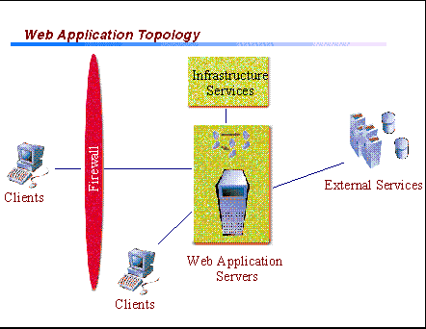
- Internet and intranet clients through which users communicate with Web application servers (using Internet standards such as TCP/IP, HTTP, and HTML) to access business logic and data. The primary role of the client is to accept and validate user input, and present results received from the Web application server to the user.
- Infrastructure services that provide the Web application server and its business logic components with directory and security services. Included in these services are firewalls which shield an organization's network from exposure when connecting to the Internet, and prevent hackers and others from gaining unauthorized access to internal data, and computing resources.
- Web application servers that are the hubs of the Web application topology processing requests from clients by orchestrating access to business logic and data on the server and returning Web pages composed from static and dynamic content back to the client. The Web application server provides a wide range of programming, data access, and application integration services for writing the business logic part of a Web application.
- External services that consist of existing, mission critical applications and data within the enterprise as well as external partner services such as payment services, financial services, and external information services. Most often these existing applications and services control the company's core business processes.
The remainder of the paper will take a closer look at each of these key components of the Framework's programming model with a focus on supported technologies and suggested design principles.

Client
Clients supported by the Framework span a diverse range of products from information appliances, such as digital telephones and PDAs, to network computers and PCs. While the individual capabilities of each of these clients vary significantly, they are unified by their reliance upon a set of Web based technologies. This set includes Java, TCP/IP, HTTP, HTTPS, HTML, DHTML, XML, MIME, SMTP, IIOP, and X.509, among others.
One of the key principles of the Framework's Web application programming model is that the business logic of a Web application always runs on the server and not on the client. This provides the following advantages:
- A broader range of client devices can be supported since the dependency on client capabilities is reduced.
- The Web application server integrates access to resources (databases, etc.) which simplifies application design, improves scalability, and provides greater security of the resources.
- Business logic running on the server is easier to protect, upgrade and maintain.
- Business logic running on the server allows users' application environments to be centrally managed and restored on different client machines (i.e. roaming user support).
Consequently, the key role of the client in the Framework's Web application programming model is to present results received from the Web application server to the user. From the client's perspective, the user interface (UI) can be driven from one of two places: either from the client or from the Web application server. This leads to the two basic client models supported by the Framework:
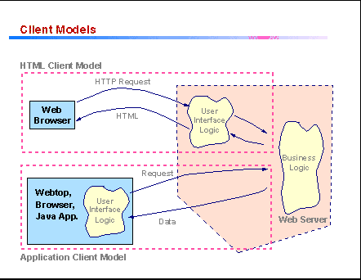
HTML Clients: The UI to be displayed on the client is generated by part of the Web application that executes on the Web application server. An HTML client interacts with a Web application server using HTTP. The server responds to every request from the client with a new HTML page. The new page can be a static or dynamically generated HTML page and it can contain Java applets, JavaScript, or DHTML.
Application Clients: The UI to be displayed on the client is generated by part of the Web application that executes on the client. An application client interacts with a Web application server using HTTP or IIOP. In response to a request from the client, the server returns data. This data is interpreted by the client and displayed. A new HTML page is not returned by the server.
The HTML client model is the most common model used in the Internet today and has several advantages:
- Any browser has the potential to run a Web application that is based upon HTTP and HTML.
- The client part of the Web application is small and downloads quickly.
- The server is able to tailor the HTML returned to the client based upon client or user attributes.
The major disadvantage of the HTML client model is the difficulty of creating highly interactive user interfaces. However, the clever use of small applets providing rich UI elements can overcome this shortcoming.
The application client model is used primarily in intranet environments and has the following advantages:
- The programming model is familiar to Web application developers with a traditional client/server background.
- Applications can be made to look more like standard windowed applications.
- The burden of generating the user interface is distributed to each client, reducing the computational load on the Web application server.
The major disadvantage of the application client model is that the client code (applets or JavaScripts) tends to be large and requires more time to download and initialize. Deployment is restricted since greater client capability and resources are required.

Web Application Server
The best way to think of a Web application is as a series of interactions between a client and a particular Web site. The entire Web interaction process begins with a single page displayed in the browser. The user clicks on a button or link on the page causing a request to be sent to the Web application server. The request is processed on the Web application server and a new page is sent back showing the results of the request and presenting buttons or links for the next request. Thus the Web application consists of a set of processing steps or interactions, each of which gets a request generated from a page and each of which must produce a response in the form of a page that will serve as the input for subsequent interactions.
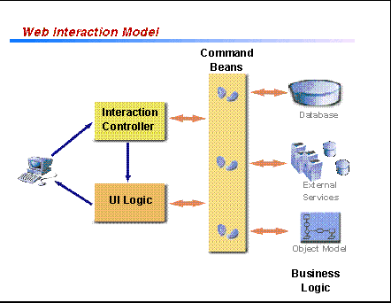
If we examine a single interaction at the next level of detail, we see a common set of processing requirements that can be nicely mapped to the classical model/view/controller paradigm as follows:
- Model - the elements of logic that actually record and process the user's input. For example, the logic that does a database update to add an item to a user's shopping cart or the logic that transfers funds from one bank account to another. We refer to this part of the interaction as the business logic.
- View - the elements of logic that construct the HTML page that is sent back to the user, thus determining the presentation form and style of the results of the interaction. We refer to this part of the interaction as the user interface (UI) logic.
- Controller - the elements of logic that control the other elements. For example, processing the HTTP request, selecting the correct model logic to run, and then, based on the results of the business logic, selecting the correct view logic to prepare the response page. We refer to this part of the interaction as the interaction controller.
Observing this mapping is important because experience has shown that the different types of logic frequently require different development skills and tools, and often need to evolve on different schedules. To this end, the Framework supports the use of different program components, with well defined interfaces between them, for each of the different types of logic.
The remainder of this section will discuss the Web application elements of interaction controller, UI logic, and business logic in more detail.

Interaction Controller
The easiest way to think about the responsibility of the interaction controller is that it is the piece of code that ties client independent business logic to a Web application. This means that the interaction controller's primary responsibility is mapping HTTP protocol specific input into the input required by the protocol independent business logic (that might be used by several different types of applications), scripting the elements of business logic together, and then delegating on to the UI logic that will create the response page to be returned to the client. Here's a list of some of the typical functions performed by the interaction controller:
- Validate the request and session parameters used by the interaction.
- Verify that the client has the necessary privileges to access the commands scripted by the interaction controller.
- Demarcate transactions.
- Script business logic components to perform required tasks. This includes mapping the request and session parameters to the business logic's input properties, and using the output to control logic flow to correctly chain the business logic.
- Invoke the appropriate UI logic based on the output of one or more of the business logic commands.
The Framework supports the development of interaction controller logic using either Java servlets or Java Server Pages (JSP) technology. [JSP technology note] Both of these implementation mechanisms have significant advantages over using CGI-BIN or Web server plugins. First of all, servlets and JSPs execute in process in the context of the Java Virtual Machine thus providing all the benefits and facilities of the Java runtime. For example, a poorly written Web server plugin application can bring down the Web server, while a poorly written servlet will throw an exception that can be caught and redirected to an error page, allowing the Web server to continue handling requests. Secondly, by their very nature, Web applications written to the Java programming model are portable across a wide range of platforms. Applications can easily be migrated without recompile between AIX, Solaris, NT, AS/400, and even System 390 operating systems. You can start an application on an NT system, outgrow it, move the application to an AIX system, outgrow it, and move it to a 390 system.
The Application Framework for e-business is centered around the philosophy that all programming resources, whether they're Enterprise JavaBeans, DB2 or Oracle databases, MQSeries, or Domino, are available in a first class way to the Java programming model. This gives the interaction controller a first class programming language and model for scripting the logic required to complete the interaction.

UI Logic
The UI logic, the view component of the application, is responsible for generating the HTML page that will be returned to the client. Like interaction controllers, the Framework supports the development of UI logic using either servlets or JSP technology. Since JSP allows HTML and Java to be mixed on the same page, it is most often the best choice for the UI logic implementation. JSP offers a template based approach, supported by visual authoring tools, for integrating dynamic data into HTML pages.
In many cases, the interaction controller will pass dynamic data to the UI logic for formatting. In other cases, the UI logic will invoke business logic directly to obtain dynamic data. It makes sense to have the interaction controller pass the data when it has already obtained it and when the data is an essential component of the contract between the interaction controller and the UI logic. In other cases, the data needed is not an essential part of the interaction, and can be obtained independently by inserting calls to business logic directly in the UI logic.
Once the UI logic has obtained the dynamic data, either from the interaction controller, or via its own logic, it will typically format the data. This can be done one of a couple of different ways. The simplest mechanism is where the data is formatted using simple scripting inside the display page. An alternative is to develop reusable script or Java object formatting components that will take a data set and return formatted HTML.

Business Logic
Given the structure suggested in the beginning of this section for Web interactions, the business logic part of an interaction is isolated from the details of Web technology. As a result, it is valuable to consider the interface between the Web parts of the interaction (interaction controllers and UI logic) and the business logic. The Framework recommends that the business logic be wrapped with JavaBeans that it calls command beans. [JavaBean note] A command bean should usually represent a single function supported by the business logic. Its usage paradigm is: create the bean, initialize by setting the bean's properties, perform by calling the bean's methods, and inspect by getting the values of the bean's properties. Using command beans of this form provides several benefits including:
- Isolation of changes - wrapping the business logic with command beans as opposed to exposing the business logic model directly allows the business logic to evolve without disrupting the rest of the Web application.
- Distribution - command beans can be serialized and sent via a protocol (IIOP, HTTP, etc.) to a remote server to be executed and then sent back. This allows for very efficient communication.
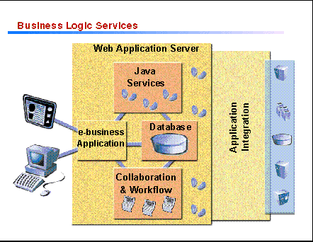
The business logic part of a Web application is the piece of code ultimately responsible for satisfying client requests. As a result, business logic must address a wide range of potential requirements which include ensuring transactional integrity of application components, maintaining and quickly accessing application data, supporting the coordination of business workflow processes, and integrating new application components with existing applications. To address these requirements and help facilitate the development of business logic on the Web application server, the Framework provides the following core services:
- Java services
- database services
- collaboration services
- application integration services
The remainder of this section will discuss each of these services in detail.

Java Services
The Framework supports business logic written in and using the full facilities of the Java runtime. The Java platform provides a wide range of programming and data access services that facilitate the development of the business logic part of a Web application. The Java platform services include:
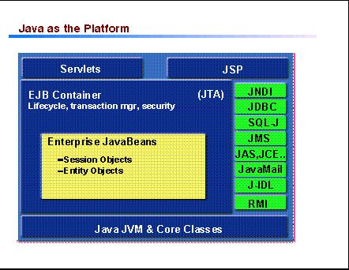
- Servlet and JSP support
- Enterprise JavaBean (EJB) support
- Database access services, the Java Database Connection (JDBC) and Java SQL (SQL-J)
- Directory access, the Java Naming and Directory Interface (JNDI)
- Security services, Java SSL (JSSL), Java Cryptography Extensions (JCE), and Java Authentication Services (JAS)
- Mail access and creation, the JavaMail API
- Java Transaction API (JTA)
- Java Messaging Services (JMS)
One of the key technologies promoted by the Framework for developing new business logic is Enterprise JavaBeans. EJB components execute on an application server within the context provided by a container. The container provides management and control functions to the component, such as security and transaction support as well as access to operating system processes and threads. Containers can be provided by Web application servers, database management systems or transaction monitors. Enterprise JavaBeans provide business logic developers with the following benefits:
- The container provides isolation of the components from the unique characteristics of the underlying services simplifying the development of business logic. As a result, business logic developers can concentrate their efforts on their core competencies.
- Enterprise JavaBeans enable components to adapt to the database and transactional services needed in many business applications, without the need for the component developers to know ahead of time which database, for example, will be used when the application is finally deployed.
The IBM WebSphere Application Server and VisualAge Java offerings provide a robust runtime and a comprehensive development environment for executing and developing business logic using Java technologies and interfaces. Since the WebSphere Application Server supports a variety of server platforms including NT, AIX, Solaris, OS/390, OS/400, and Linux, business logic which uses the full range of Java services can be easily ported to the platform that best meets your scalability and quality of service requirements.

Database Services
Database services integrate the features and functions of an object-relational database with those of the Web application server. This provides a facility for managing both the operational data and multimedia content used to support intelligent decision making within a company and to conduct business on the Internet, an intranet, or an extranet. The Framework extends the standard Java relational database access mechanisms, JDBC and SQL-J, with connection caching which greatly improves application throughput and response time by maintaining a cache of open connections to the database. Specifically, Framework database services:
- Manage both traditional data (record-structured alphanumeric data) and nontraditional data (such as text, multimedia, spatial, etc.) along with user defined data types for specialized business requirements.
- Combine the ability to define complex data types and associated functions with relational database features such as multiple views, structured query and fine-grained update concurrency.
- Support development and execution of database application programs, stored procedures and user defined functions using the Java and JavaBeans programming model
- Provide query and update access to database information using SQL, SQL-J, and JDBC interfaces; this includes Web applications updating the database using two-phase commit
- Integrate transaction services with databases using the Open Group's XA reference model standards
The IBM DB2 Universal Database provides support for all these key features. It is fully Web-enabled with built-in Java support, scalable from single processors to symmetric multiprocessors to massively parallel clusters, and features multimedia capabilities with image, audio, video, text and other advanced object relational support.

Collaboration Services
The primary focus of collaboration services is to provide a rich shared virtual workspace and to support the coordination of business workflow processes. Collaboration services integrate information from any resource, manage what is shown to users, confer a measure of interactivity between information and the user, and manage the content through a business process in which employees, customers, and business partners can participate. Collaboration services accelerate the flow of information through an organization's decision making and approval processes.
Collaborative applications excel at connecting existing structured business data and transaction systems with people to create new business processes and workflows. Comprehensive application services like workflow and messaging are supported, so you can easily build and manage integrated, collaborative solutions. Workflow services allow you to easily define processes to route and track documents, and to coordinate activities both within and beyond your organization.
The de facto standard for implementing collaborative applications is defined by the Lotus Notes API. The Domino Application Server is an open, secure platform optimized to deliver collaborative Web applications that integrate your enterprise systems with rapidly changing business processes.

Application Integration
Application integration services address the need to Web-enable existing computing assets as well as the need to intelligently integrate business processes (applications built on disparate architectures) across the whole business. The Framework provides the following methods of application integration:
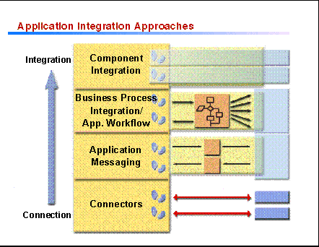
- Connectors are gateway software that provide linkage between the Web application server and services that are reached through the use of application specific protocols.
- Application messaging services provide message-based communication between applications with assured delivery of messages.
- Business process integration and workflow services extend the base messaging services with message brokering, intelligent message routing, and message translation.
- Component integration services enable object wrappering of existing application logic written in any language. As a result, existing application logic is extended to object-oriented environments.
Connectors greatly reduce the complexity and cost of developing mission critical Web applications because in many cases the hard transactional business logic is complete and already running in a robust, managed environment. Connectors are Java libraries and supporting tools that support access from the Framework's programming environment to various external data and application servers. They shield the programmer from the usually proprietary network protocols needed to access these servers. e-business connectors from IBM provide a comprehensive set of connectors to a wide range of existing application and data servers including CICS, Encina, IMS, DB2 and other relational databases, Domino, and MQ.
Application messaging services provide reliable transfer of information between computer applications, regardless of the type of computer or network. Using these services, it is generally straightforward to connect an application to another, with only simple programming needed to establish full two-way communication. It is not necessary for both applications to be running at the same time which means that the two applications can operate independently of each other, each handling requests from the other when they are ready to do so. Messages sent are assured of delivery, once and once only. Where data has a high intrinsic value, like financial transactions, this is of immense importance. IBM's innovative, award winning MQSeries is the market leader in commercial messaging, supporting over 35 platforms and setting the standards against which messaging products are judged.
Unlike messaging services which require direct connections between systems, business process integration and workflow services provide a central hub to which each system has a single connection. The maze of connections dramatically simplifies to a star diagram -- and the center of the star becomes the focus for the extra layer of business process integration capability. The business process integration hub maintains two types of knowledge: knowledge of the business, including processes and rules by which the business is run; and knowledge of the applications in the enterprise systems. This knowledge allows the hub to take action, based on the type of messages that come in. Knowledge of business processes makes intelligent routing possible; and knowledge of the applications enables translation of message formats. XML plays a key role in the message translation process. IBM provides powerful message brokering software with MQSeries Integrator while MQSeries Workflow simplifies integration across the whole enterprise by automating business processes involving people and applications.
Component integration services enable object wrappering of existing application logic extending this logic to object oriented environments. New applications can be built by linking together applications from all over the enterprise and combining them with transactional support. It becomes completely transparent, both to the end user and to the developer, which system they are actually using and allows a high degree of flexibility in building new applications. The Component Broker support in IBM WebSphere Application Server, Enterprise Edition provides a robust runtime and toolset for simplifying the integration of existing assets with object oriented applications.

Web Application Infrastructure
In addition to the programming mechanisms discussed above, application developers need certain runtime services to support Web applications. The ability to easily locate application components, access and execute them securely, and ensure their availability are critical factors to deploying Web applications in Internet, intranet, and extranet environments. As a result, the Framework provides the following facilities to support Web applications.
- Directory support - the Framework supports JNDI access to highly scalable, sharable, secure directory services using the industry standard LDAP protocol. IBM is working with industry standards groups such as the IETF and DMTF to help define standard schema definitions. Defining and supporting common standards based schema for key objects such as users, groups, roles, and network policies allows applications to be written independent of specific directory implementations. Another important component of directory support is the meta directory which synchronizes information between the different directories in an organization, allowing users accessing any of the directories to see the same information. IBM eNetwork Directory, a SecureWay Software offering, provides a robust, scalable, standards based LDAP directory implementation.
- Certification authority - this facility produces security certificates that can be used to authenticate users and/or servers. Public key infrastructure (PKI) technology is emerging as the preferred trust mechanism for networked business. A key component of PKI is the certification authority that provides digital credentials and security features such as message integrity, data privacy, signature verification, and user authentication. Certificates, with associated roles and privileges, registries to manage certificates, and key pairs to support digital signing and encryption provide the quantum step-up in capability needed to reconcile the Internet / security compromise. The IBM Vault Registry, a Secureway Software offering, is a security-rich, integrated certification and registration solution that builds trust into business-critical Web applications.
- Firewall support - the firewall acts as a secure interface between your private, trusted network and one or more external, untrusted networks. Firewalls use filters to permit/deny packet flow on the basis of the origin/destination of the packet's addresses and ports. You can use the firewall to control who in your trusted network is permitted to access external networks, which application services they can use, and which specific external hosts they can access. The same controls are also used to limit access to trusted networks. When properly configured to implement a judicious security policy, firewalls can protect your network from intrusion and compromise. Firewalls are also key to the support of Virtual Private Networks (VPN) which allow the trusted network to use the Internet as a WAN to make secure connections to other networks. This is accomplished by the firewall encrypting all traffic between the firewall and other compatible systems, under the control and selection of the administrator. IBM eNetwork Firewall, a SecureWay Software offering, enables safe, secure e-business by controlling all communications to and from the Internet.
- Proxy server - the proxy server assumes the responsibility of retrieving Internet data for multiple browser clients. It acts as a conduit between the client and Web application server forwarding client requests to the server and returning server responses to the client. This way the proxy function can be used to provide address security. Proxy servers also provide caching functionality which allow it to serve subsequent client requests for cached documents from its local cache. The client gets the information faster and network bandwidth utilization is reduced. IBM Web Traffic Express, part of the IBM WebSphere Performance Pack, is a caching proxy server that provides highly scalable caching and filtering functions associated with receiving requests and serving URLs.
- Network dispatcher - sometimes referred to as an IP sprayer, a network dispatcher allows heavily accessed Web sites to increase capacity by linking many individual servers to a single, logical server. The Web site appears as a single IP address, and functions independently of the Domain Name System to achieve optimal scalability and availability. Determining which server a request should be connected to can be determined by rules-based load balancing. The IBM Secureway Network Dispatcher, part of the IBM WebSphere Performance Pack, increases throughput and availability with dynamic, rules-based load balancing.

Summary
In summary, the Application Framework for e-business provides a comphrensive, Java based platform for developing Web applications that:
- simplifies application development and deployment,
- supports heterogeneous client and server platforms,
- leverages existing skills and assets,
- delivers a secure, scalable, reliable, and manageable environment, and
- provides the freedom to implement using many vendor's products, including products from IBM.

Notes
JSP Technology Note: JSP scripting provides a way to add server-side scripting logic directly into the HTML of a response page. JSP scripting can be used to do fine grained control of the content such as conditionally making a word plural based on a dynamic value such as the number of items added to a shopping cart. It also offers a simpler mechanism for writing a small amount of program logic than a full blown servlet, as JSP pages don't require standard programming steps such as compilation. JSP scripting is a very powerful mechanism that provides the full power of Java in the simple form of scripting within an HTML page. In fact, developers can implement their entire application using only JSP, without ever writing a single explicit servlet, since JSP files are automatically translated into Java servlets when executed.
The basic concept of JSP scripting is very simple. A set of HTML tags are defined that allow the developer to indicate inline Java code. The scripted page is converted into a Java servlet on first reference, thus JSP is very efficient, not requiring any runtime parsing as is required for server-side includes. And it is open ended because the scripter has complete access to the Java execution environment including the execution context, database access, etc. This model also preserves the integrity of the Java environment as it does not require a new set of object libraries or a new execution model just to support scripting.
While JSP supports server-side scripting using Java, the JSP tags were designed to allow other languages to be used such as JavaScript, Basic, and REXX. However, the basic model of translation into a Java servlet is always preserved.
JavaBean Note: JavaBeans play an important role in the Framework's programming model because they provide a standard model for customizable components supported by a wide range of tools. JavaBeans are defined as Java classes that have a number of properties. Usually each property can be set in a instance of the bean class and then the instance can be serialized (encoded as a byte stream) and saved to a file or database. There are a number of tools called property editors that can assist in this activity. The serialized beans are named just like Java classes (e.g., com.ibm.Framework.ABean) and they can be located using the class path just like Java classes. Java provides a mechanism for loading a bean instance by deserializing a previously saved bean. Thus, when an application element needs to contain runtime constants such as URLs, or database IDs that might need to be customized, it is best realized as a JavaBean with a setable property for each of the constants. The user of the element can create an instance of the bean class, customize it by setting the appropriate properties and save the result. When the runtime needs the application element it will "load" the bean getting a copy of the customized bean.

References
- For general information on the Framework, visit the Application Framework for e-business Web site (www.software.ibm.com/ebusiness).
- For detailed technical information on servlets, JSPs, other Java services, and performance related infrastructure services visit the IBM WebSphere site (www.software.ibm.com/webservers/).
- For information about VisualAge for Java visit www.software.ibm.com/ad/vajava.
- For information on the Domino Application Server visit http://www.lotus.com/home.nsf/tabs/domino.
- For information on the IBM DB2 Universal Database visit http://www.ibm.com/software/data/db2/udb/.
- For detailed information about the e-business connectors visit http://www.ibm.com/software/webservers/connectors/.
- For detailed information on application messaging, business process integration, and application workflow, visit the MQSeries site (http://www.ibm.com/software/ts/mqseries/).
- For detailed information on directory and security infrastructure services, visit the Secureway site (http://www.ibm.com/software/secureway/).

